**Experiment 2:**

T Raja Aadhithan

602162021

**1, Create a file named testVI1.txt in the CAD folder created last time. Type minimum of 2 paragraphs of 10 lines at least.**

cad folder before the creation of file:

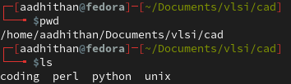

cad folder after the creation of file:

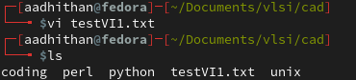

The text file created:

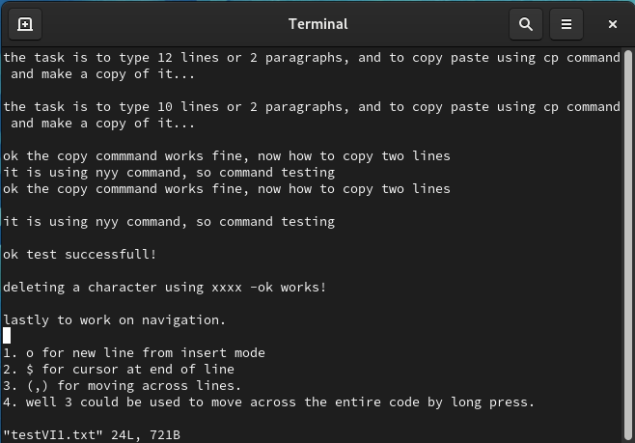

**2, Use the cp command to create the copy of the file.**

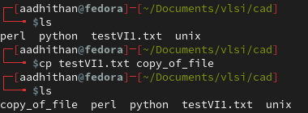

**3, Try out opening the second file in read only mode and delete it later**

Before changing user preferences:

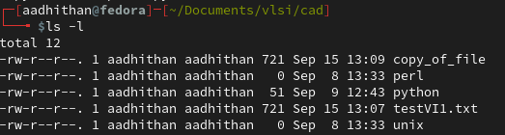

Changing preferences:

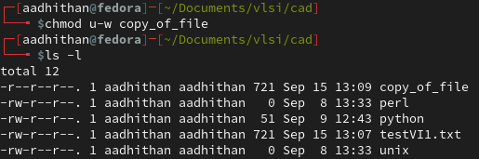

Deleting the file:

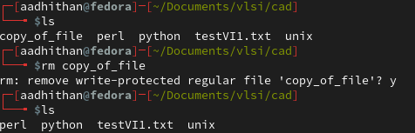

**4, Inside the file**

Ways to come out of the file:

1.  q - Quits without saving.

2.  wq - Quits after saving the new values in the file.

3.  q! - Quits and overwrites the value newly type to restore previous version.

Used various key for navigation:

1. o for new line from insert mode

2. $ for cursor at end of line

3. (,) for moving across lines.

4. well 3 could be used to move across the entire code by long press.

Copy paste using yy and p command:

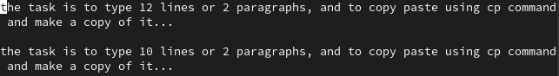

Deleting in the file:

1. x deletes the letter the cursor is pointing

2. dd deletes the line

3. ndd deletes n number of lines from the cursor position